2018年吉林特岗教师招聘模拟卷三

第II卷 中小学英语

一、判断题（每小题1分，共10分。正确的在题后括号内打“√”，错误的打“×”）
1.义务教育阶段的英语课程具有科学性和人文性双重性质。 （ ）
2.以语言技能、语言知识、情感态度、学习策略和文化意识等五个方面共同构成的英语课程总目标，既体现了英语学习的工具性，也体现了其人文性。 （ ）
3.语言技能五级目标中要求学生课外阅读量应累计达到15万词以上。 （ ）
4.教师在教学中要不断激发并强化学生的学习兴趣，引导学生逐渐将兴趣转化为稳定的学习动机。 （ ）
5.资源策略是学生合理并有效利用多种媒体进行学习和运用英语的策略。 （ ）
6.在外语教学中，文化是指所学语言国家的历史地理、风土人情、传统习俗、生活方式、行为规范、文学艺术、价值观念等。 （ ）
7.小学英语教学评价应以课程标准和平时的教学内容为依据，以激励学生的学习兴趣为主要目的，采用符合学生认知水平、具有多样性和可选择性的评价形式。 （ ）
8.评价的内容与标准要以学生所学的知识为标准。 （ ）
9.教学活动应有利于英语学科和其他学科的渗透与联系，以促进学生的认知能力、思维能力、审美情趣、想象力和创造力等素质的综合发展。 （ ）
10.英语教学应有利于学生理解异国文化、形成跨文化意识、拓展文化视野，同时加深对中华民族优秀传统文化的理解与热爱。 （ ）

二、短文改错题（每小题1分，共10分）
本题要求改正所给短文中的错误。请对标有题号的每一行作出判断：如无错误，在该行右边横线上打一个勾（√）；如有错误（每行只有一个错误），在错的词下面划一横线，在该行右边横线上写出改正后的词；如此行缺一个词，在缺词处加上一个漏字符号（∧），在该行右边横线上写出该加的词；如此行多一个词，把多余的词用斜线（\）划掉，在该行右边横线上写出该词，并也用斜线划掉。

We use both words and body language express our thoughts and 11.___________
opinions and to communicate with other peoples. 12.___________
We can learn a lot of about what a person is thinking by 13.___________
watch his or her body language. Words are important, 14.___________
but the way a person stands, folds his or her arms, or moved his or 15.___________
her hands can also give us informations about his or her feelings. 16.___________
Just like speaking language, body language 17.___________
vary from culture to culture. Making eye contact — looking directly 18.____________
in someone's eyes — is in some countries a way to show interest. 19.____________
In another countries, however, eye contact is a way to show 20.____________
that a person is rude or disrespectful.

三、完型填空题（每小题1分，共20分）
阅读下面短文，掌握其大意，然后从21-40各题所给出的四个选项中选出一个最佳答案，把相应的字母序号写在括号中。
Because conflict and disagreements are part of all close relationships, couples need to learn strategies for managing conflict in a healthy and constructive way. Some couples just __21__ and deny the presence of any conflict in a relationship. __22__, denying the existence of conflict results in couples __23__ to solve their problems at early __24__, which can then lead to even greater problems later __25__. Not surprisingly, expressing anger and disagreement leads to lower marital satisfaction at the beginning. However, this pattern of behavior __26__ increases in marital satisfaction over time. Research suggests that working __27__ conflicts is an important predictor of marital satisfaction.
So, what can you do to manage conflict in your own relationships? First, try to understand the other person’s point of view __28__ put yourself in his of her place. People who are __29__ to what their partner thinks and feels __30__ greater relationship satisfaction. For example, researchers found that among people in dating relationships __31__ marriages, those who can adopt their partner’s perspective show more positive __32__, more relationship-enhancing attributes and more constructive responses __33__ conflict.
Second, because conflict and disagreements are an __34__ part of close relationships. People need to be able to apologize to their partner for wrongdoing and __35__ forgiveness from their parents for their own acts. Apologies minimize conflicts, lead to forgiveness, and serve to restore relationship closeness. In line __36__ this view, spouses who are more forgiving show higher mental __37__ over time. Increasingly, apologizing can even have __38__ health benefits. For example, when people reflect on hurtful __39__ and grudges, they show negative physiological effects, including __40__ heart rate and blood pressure, compared to when they reflect on sympathetic perspective-taking and forgiving.
（ ）21. A. resolve B. regret C. abandon D. avoid
（ ）22. A. Besides B. Therefore C. Moreover D. However
（ ）23. A. trying B. declining C. failing D. striving
（ ）24. A. ages B. years C. stages D. intervals
（ ）25. A. on B. by C. off D. away
（ ）26. A. prescribes B. protests C. proves D. predicts
（ ）27. A. round B. amid C. among D. through
（ ）28. A. so B. while C. but D. and
（ ）29. A. sensitive B. superior C. exclusive D. efficient
（ ）30. A. expose B. experience C. explore D. exploit
（ ）31. A. as long as B. as far as C. as well as D. as soon as
（ ）32. A. minds B. emotions C. psychology D. affection
（ ）33. A. to B. against C. at D. toward
（ ）34. A. absolute B. inevitable C. essential D. obvious
（ ）35. A. require B. inquire C. receive D. achieve
（ ）36. A. over B. with C. up D. of
（ ）37. A. quality B. positive C. memories D. outlooks
（ ）38. A. creative B. positive C. objective D. competitive
（ ）39. A. prospects B. concepts C. memories D. outlooks
（ ）40. A. added B. toughened C. strengthened D. increased

四、阅读理解题（共15分）
A
Throughout the world, clothing has many uses. It is used to provide protection from cold. It is also worn to prevent others from seeing specific parts of one’s body. However, the parts of the body that must be covered vary widely throughout the world. Some clothing is worn to provide supernatural protection. Wearing a lucky shirt to take an exam is calling for supernatural assistance.
People in all cultures use clothing and other forms of bodily decoration to communicate status (身份), intentions and other messages. In North America, we dress differently for business and various leisure activities. North American women usually are much more knowledgeable of little difference in messages communicated by clothes than men. At times, this leads to silly mistakes of understanding of female intentions on the part of men. Of course, clothing styles also are intended to communicate messages to members of the same gender (性别).
Long before we are near enough to talk to someone, their appearance tells their gender, age, economic class, and often even intentions. We begin to recognize the important cultural clues at an early age. The vocabulary of dress that we learn includes not only items of clothing but also hairstyles, jewelry, and other body decoration. In most cultures, however, the same style of dress communicates different messages depending on the age, gender, and physical appearance of the individual wearing it.
Putting on certain types of clothing can change your behavior and the behavior of others towards you. This can be the case with a doctor’s white lab coat, or an army uniform. Most uniforms are clearly symbolic so that they can rapidly and unmistakably communicate status. For instance, the strange hairstyle and clothing of the English “punks” are essential aspects of their uniforms.
There are many forms of body decoration other than clothes that are used around the world to send messages. These include body and hair paint, and even body deformation. When doctors put braces on teeth, they are actually doing the same thing – deforming or reforming a part of the body to make it more attractive.
根据短文内容，选择正确答案，把相应的字母序号填在后面的括号中。（每小题1分）
41. Which of the following is the best title for this passage?
A. Clothing and Culture
B. Ways of Sending Message
C. Clothing and Social Behavior
D. Communication through Clothing
42. Some people wear lucky shirts to take an exam because they believe _____.
A. clothes can hide their fear for the exam
B. clothes have extraordinary power
C. shirts can make them more comfortable
D. shirts provide protection against bad weather
43. In North America, men sometimes misunderstand women’s intention because _____.
A. men are more careless than women
B. women spend more time on their clothes
C. men and women have different views on clothing styles
D. men care less about the different messages communicated by clothes
44. According to the passage, the behavior of others towards you can be changed by your _____.
A. age B. dress C. status D. gender
45. From the passage, it can be inferred that ____.
A. clothing plays an important role in social activities
B. words of dress are unable to communicate different messages
C. dress is better than language in communicating messages
D. messages communicated by clothes are the same in different cultures
B
Everyone wants something in life, love, money, success...Yet too many people fail to achieve their goals, and nearly all of them are for the same reason.
It’s true that terrible things do happen to people during their lives, though no fault of their own, which may make them feel upset. Generally speaking, however, getting what you really want out of life is just a matter of the following three simple steps.
Firstly, you have to decide what it is you want the most. But do not make a list of wishes; try to focus on one thing at a time. If you’re not sure about where you want to go, you’d better think it over first and not hurry to perform.
Secondly, create an action plan. This will be your map for getting from “________” to “where you want to go”. You know what you want, and what steps you are going to take to get it. For example, if you want a better job, start with a skills assessment (评估) and maybe some extra training. Then you’ll need to sell yourself and your skills either to your present employer or to a new employer.
Other goals will require a bit more thought. Some will really get you lost without a clue of how to get there. Not to worry, though, books, biographies and such, can be of great help.
The third and final step is to execute. Do what you planned. Take the steps you outlined on your road map and keep going on all the time. If you run into some people who are against you, simply ignore them.
Never give up the goal. Keep pushing. Whatever you do, do not lose heart until you have what you desire in your hands. Never think that you can’t turn your dream into a reality.
根据短文内容，用英语回答下列问题。（每小题2分）
46. What does the author want to tell readers in this article?
_____________________________________________________________________
47. Fill in the blank in Paragraph 4 with proper words.
_____________________________________________________________________
48. List the three simple steps that you should take if you want to achieve your goals.
_____________________________________________________________________
49. What is the most important thing when you decide what to do?
_____________________________________________________________________
50. What does the underlined word “it” in paragraph 3 probably refer to?
_____________________________________________________________________

五、书面表达题（共15分）
51.假如你是某报的记者，对近来大学生所持的就业观点向有关专家进行了采访。请根据下列要点为报社写一篇报道。词数120左右，可适当添加细节使行文流畅。
学生观点：
（1）部分学生想找一份薪金丰厚(well paid)的工作。
（2）部分人持观望态度，等待良机。
（3）少数想自己创业(start one’s own business)。
专家意见：
（1）不应该坐等时机，要尽快找一份工作，理由是：①积累经验。②赚钱养活自己。③明年就业形势或许会更严峻。
自己的看法：

六、教学设计题（共10分）
52.阅读下面所给的教材内容，用英文完成一课时的教学设计方案，内容包括：教学目标、教学重点、教学难点、教学过程和板书设计五个方面。
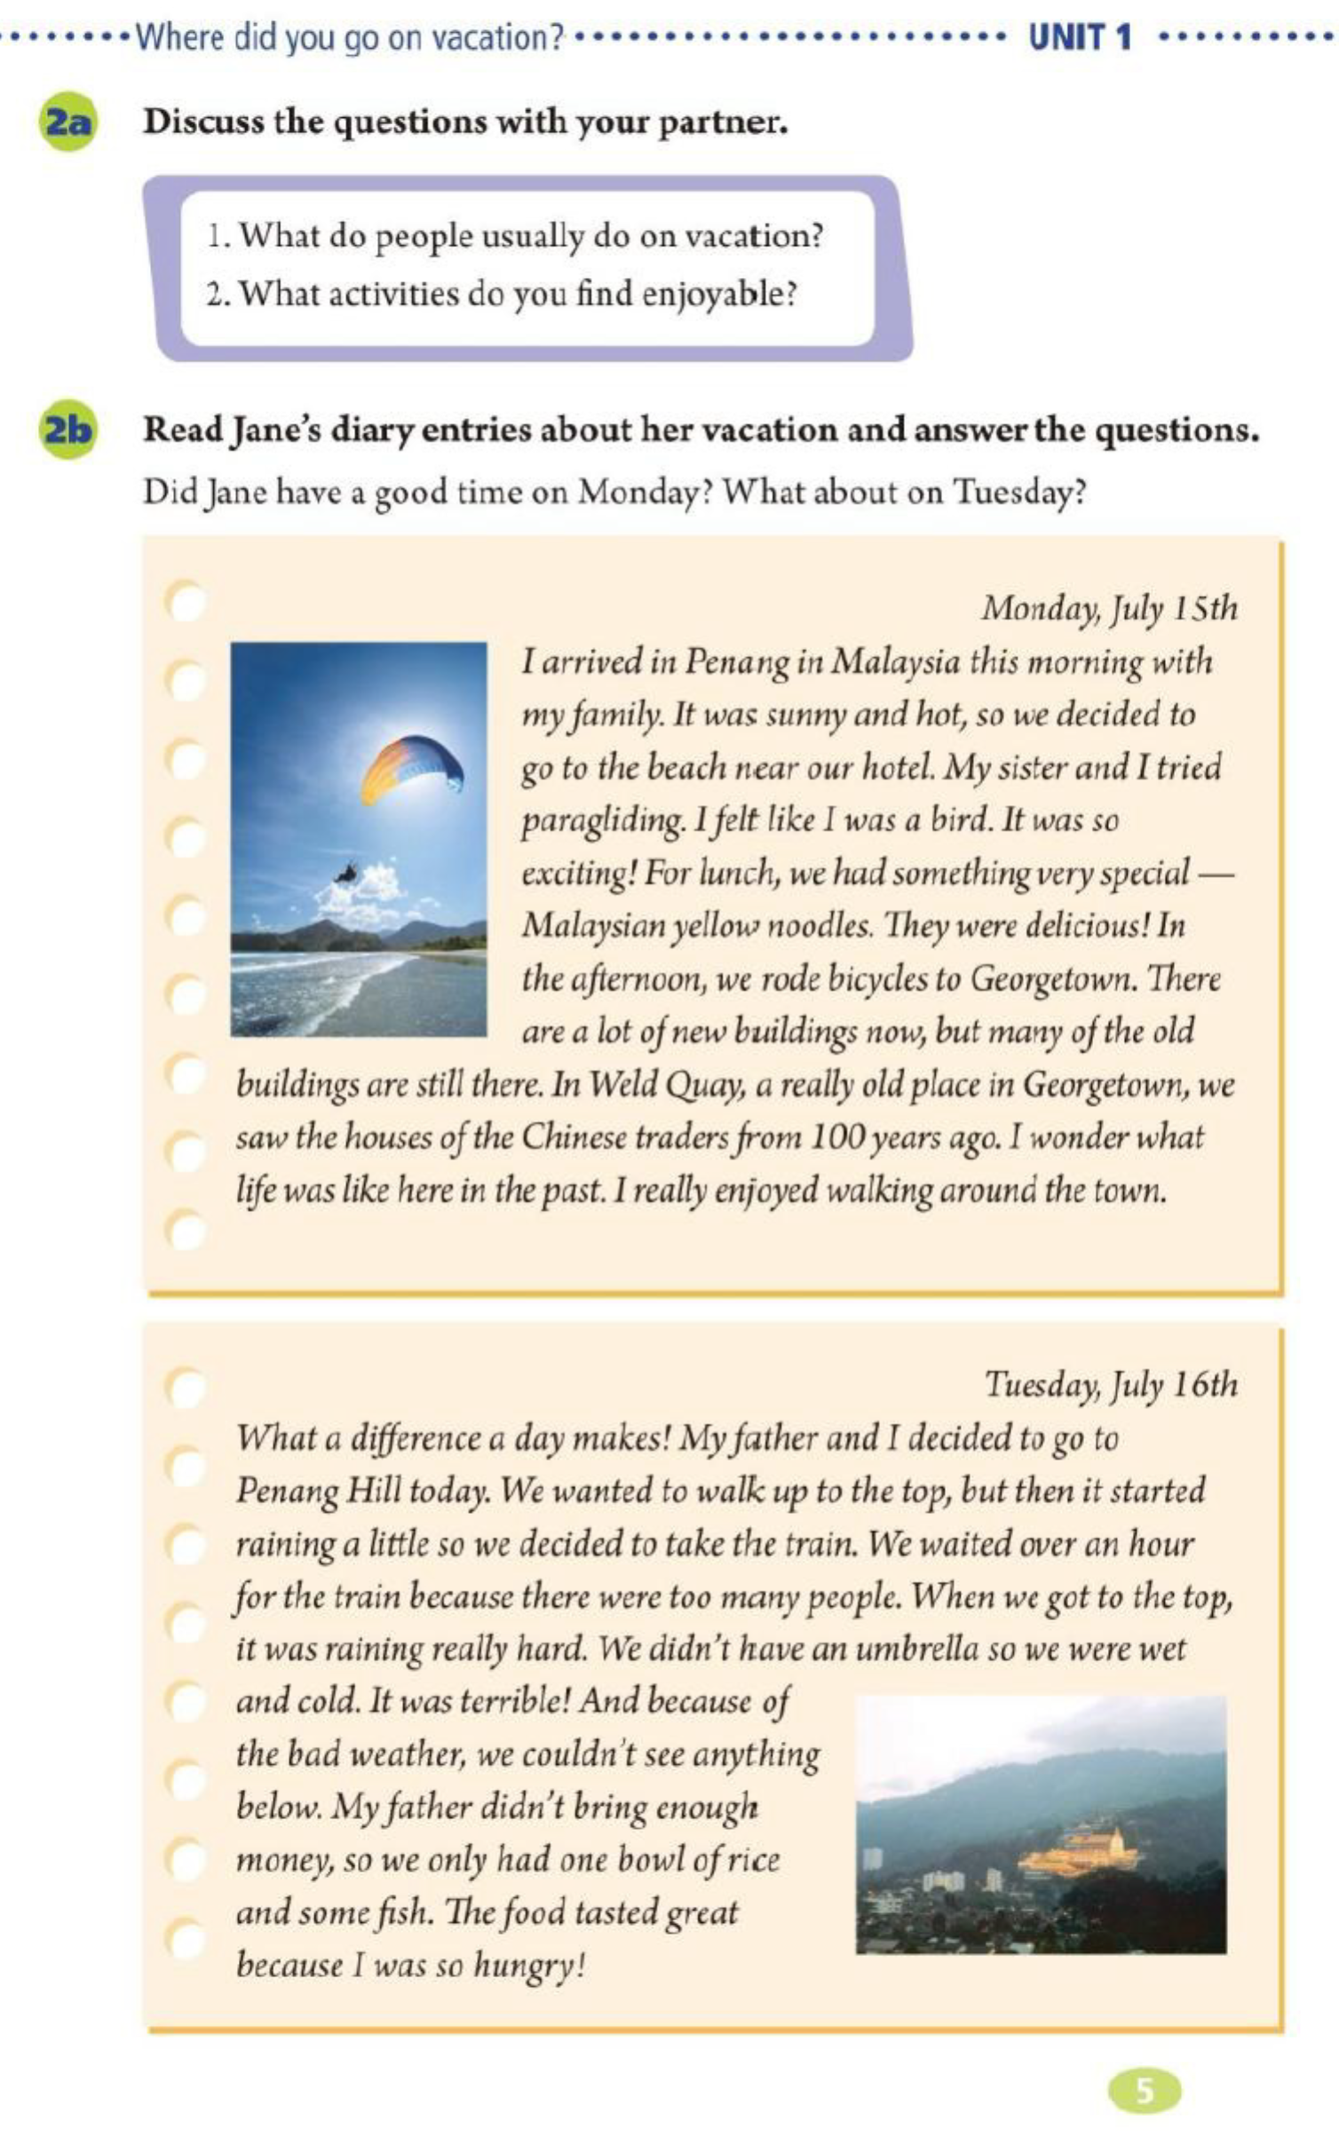
Teaching Plan
I. Teaching Aims / Objects / Goals:
_____________________________________________________________________________________
_____________________________________________________________________________________
_____________________________________________________________________________________
II. Teaching Important Points:
_____________________________________________________________________________________
_____________________________________________________________________________________
III. Teaching Difficult Points:
_____________________________________________________________________________________
_____________________________________________________________________________________
IV. Teaching Procedures:
_____________________________________________________________________________________
_____________________________________________________________________________________
_____________________________________________________________________________________
_____________________________________________________________________________________
_____________________________________________________________________________________
_____________________________________________________________________________________
_____________________________________________________________________________________
_____________________________________________________________________________________
_____________________________________________________________________________________
_____________________________________________________________________________________
_____________________________________________________________________________________
_____________________________________________________________________________________
_____________________________________________________________________________________
_____________________________________________________________________________________
_____________________________________________________________________________________
_____________________________________________________________________________________

V. Blackboard Design:

