2018年吉林特岗教师招聘模拟卷二

第II卷 中小学英语

一、判断题（每小题1分，共10分。正确的在题后括号内打“√”，错误的打“×”）
1.在《英语课程标准》九级目标体系中，第五级为九年级结束时应达到的基本要求。 （ ）
2.《英语课程标准》将课程目标设定为九个级别并以学生“能用英语做事情”具体描述各级别的要求，这种设计旨在体现基础教育阶段能力发展循序渐进的过程和课程要求的有机衔接，保证国家英语课程标准的整体性、灵活性和开放性。 （ ）
3.在英语教学过程中应以终结性评价为主，着重检测学生综合语言运用能力。 （ ）
4.形成性评价注重培养和激发学生学习的积极性和自信心。 （ ）
5.在英语笔试中，试题的配置要采取客观性和主观性相结合的形式。 （ ）
6.基础教育阶段英语课程的总体目标是培养学生的综合语言运用能力。 （ ）
7.《英语课程标准》语言技能四级目标中，要求学生的课外阅读量应累计达到15万词以上。 （ ）
8.义务教育阶段学生应该学习和掌握的英语语言基础包括语音、词汇、语法、功能和话题等五个方面。 （ ）
9.《全日制义务教育英语课程标准》中的情感态度是指兴趣、动机、自信、意志和合作等影响学生学习过程和学习效果的相关因素。 （ ）
10.保持积极的学习态度是英语学习成功的关键。 （ ）

二、短文改错题（每小题1分，共10分）
本题要求改正所给短文中的错误。请对标有题号的每一行作出判断：如无错误，在该行右边横线上打一个勾（√）；如有错误（每行只有一个错误），在错的词下面划一横线，在该行右边横线上写出改正后的词；如此行缺一个词，在缺词处加上一个漏字符号（∧），在该行右边横线上写出该加的词；如此行多一个词，把多余的词用斜线（\）划掉，在该行右边横线上写出该词，并也用斜线划掉。
To everyone in the world, money was a sensitive topic. 11._______
Not one can live without money in modern society. People 12._______
has different opinions on it. Some people think one should 13._______
live to make money, when others make money to live. 14._______
In my opinion, the latter should reasonable. 15._______
We should not be the slave of money. Although money 16._______
means a lot in our life, but it does not mean everything. 17._______
We can’t exchange it for friendship or love. Money indeed could 18._______
make a person enjoying his life for a while but not all his life. 19._______
On a word, money is something but not everything. 20._______

三、完型填空题（每小题1分，共20分）
阅读下面短文，掌握其大意，然后从21-40各题所给出的四个选项中选出一个最佳答案，把相应的字母序号写在括号中。
A person may have a false idea about himself that will stop him from doing good work.
He may have the belief that he is unable to do it. A child may think he is __21__ because he doesn’t understand how to make __22__ use of his mental gifts. Old people may have a false idea that they are unable to learn things new because of their __23__.
A person who believes that he is stupid will not make a real __24__ because he feels that it would be useless. He won’t go at a job with confidence necessary for __25__. Besides, he won’t work his hardest way, even though he may think he is doing so. __26__, he is likely to fail, and the failure will __27__ his belief in his incompetence (无能) in turn.
Alfred Alder, a famous doctor, had __28__ like this. When he was a small boy, he had a poor __29__ in math. His teacher told his parents he had no ability in math in order that they would not __30__ too much of him. In this way, his teacher and parents __31_ the idea. He __32__ their false judgment of his ability, feeling that it was useless to __33__. Then, he was very poor at math, __34__ as they expected.
But one day everything changed. He worked out a problem which __35__ of the other students had been able to solve. He __36__ in solving the problem which gave him confidence (信心) Soon he became especially good at __37__.
Alder now __38__ with interest, determination and purpose. He not only proved that he could learn math well, but luckily he learned it __39__, not too late. From his own experience, we can tell that if a person goes at a job with determination and purpose, he may __40__ himself as well as others by his ability.
（ ）21. A. stupid B. shy C. useless D. clever
（ ）22. A. big B. full C. high D. straight
（ ）23. A. ability B. age C. brain D. knowledge
（ ）24. A. decision B. plan C. promise D. effort
（ ）25. A. work B. study C. pleasure D. success
（ ）26. A. Therefore B. Really C. However D. Truly
（ ）27. A. lead to B. strengthen C. improve D. get rid of
（ ）28. A. a thought B. an example C. an experience D. an idea
（ ）29. A. state B. mind C. start D. ending
（ ）30. A. blame B. expect C. get D. win
（ ）31. A. discovered B. organized C. developed D. found
（ ）32. A. broke B. refused C. doubted D. accepted
（ ）33. A. manage B. argue C. act D. tryst
（ ）34. A. only B. almost C. just D. then
（ ）35. A. none B. all C. some D. most
（ ）36. A. succeeded B. broke C. failed D. believed
（ ）37. A. physics B. medicine C. English D. math
（ ）38. A. studies B. plays C. works D. graduates
（ ）39. A. early B. deeply C. late D. simply
（ ）40. A. discourage B. love C. surprise D. disappoint

四、阅读理解题（共15分）
A
Rae and Bruce Hostetler not only work very hard, they also relax just as well. Numerous vacations help the couple to maintain their health and emotional well-being, and it’s no surprise to health care professionals.
“Rest, relaxation, and stress reduction are very important for people’s well-being and health. This can be accomplished through daily activities, such as exercise and meditation, but vacation is an important part of this as well,” said primary care physician Natasha Withers from One Medical Group in New York. Withers lists a decreased risk of heart disease and improved reaction time as some of the benefits from taking some time off. “We also know that the mind is very powerful and can help with healing, so a rested, relaxed mind is able to help the body heal better,” said Withers.
Psychologists confirm the value of vacations for the mind. “The impact that taking a vacation has on one’s mental health is great,” said Francine Lederer, a clinical psychologist in Los Angeles who specializes in stress and relationship management. “Most people have better life perspective and are more motivated to achieve their goals after a vacation, even if it is a 24-hour time-out.” The trips could be good for their health, good for their family and good for their businesses.
The online travel agency Expedia conducted a survey about vacation time in 2010, and according to their data the average American earned 18 vacation days—but only used 14 of them. France topped the list, with the average worker earning 37 vacation days and using all but two of them. Americans’ responses may not be surprising in a culture where long hours on the job often are valued, but that’s not always good for the individual, the family or the employer.
Psychologists have also found that people who don’t take enough time to relax may find it harder to relax in the future. “Without time and opportunity to do this, the nerve connections that produce feelings of calm and peacefulness become weaker, making it actually more difficult to shift into less-stressed states,” Mulhern said.
根据短文内容，选择正确答案，把相应的字母序号填在后面的括号中。（每小题1分）
41. How did the author introduce the topic of the text? （ ）
A. By making comparisons. B. By giving an example.
C. By raising questions. D. By providing data.
42. According to Natasha Withers, vacations can ________. （ ）
A. weaken reaction system B. cure serious diseases
C. reduce the level of well-being D. decrease the risk of heart disease
43. Expedia’s survey shows that Americans ________. （ ）
A. dislike family gatherings
B. have the shortest vacation
C. enjoy as many vacations as the French
D. think much of spending long hours on the job
44. What can be inferred from the last paragraph? （ ）
A. One should never wait to relax.
B. Work and rest go against each other.
C. Time and opportunity wait for no man.
D. A relaxed mind determines everything.
45. What is mainly talked about in the text? （ ）
A. Ways to relax in one’s free time. B. The benefits of taking time off.
C. Different opinions on holidays. D. The Hostetlers always on the go.
B
To most of us, school means classes, teachers, schedules, grades, and tests. But for the children at Sudbury Valley School in Massachusetts, school is very different.
Firstly there are no lessons. All the children, aged between 4 and 19, do whatever they want. There are no teachers — only “staff members”. The idea behind this is that you do not need to make children learn, because children want to learn anyway. “You do not need to say to a three-year-old, ‘Go to explore your environment.’ You can’t stop them!” says Daniel Greenberg, a founder of the school. “But if you make children do what you want all day, they will lose all taste for learning.”
At Sudbury Valley School, you will permit children to talk, read, paint, cook, work on computers, study French, play the piano, climb trees or just run around. Two boys spent three years just fishing!
The other way that Sudbury Valley School is different is that the children can decide the rules. Every week, there is a school meeting where both children and staff have one vote each — even four-year-olds. They decide the school rules, how to spend the school budget, and even which staff they want and do not want any more.
When the school first opened in 1968, people said it would never work. But today, the school has 200 students, and 80% of its students go to college. Even the two boys who went fishing all the time have successful careers today. One of them is a musician and the other is a computer scientist.
根据短文内容，用英语回答下列问题。（每小题2分）
46. What is the main topic of the article?
__________________________________________________________________________
47. What does the school believe?
__________________________________________________________________________
48. What does Daniel Greenberg say about three-year-olds?
__________________________________________________________________________
49. Who has the most power in the school meetings?
__________________________________________________________________________
50. What happens to the children after they leave this school?
__________________________________________________________________________

五、书面表达题（共15分）
51.请以“Which Mode of Travel Do You Like?”为题，根据下面提示，写一篇不少于120词短文，要求包括下列三点内容。
（1）有的人喜欢参加旅行社旅游（package tours）；
（2）有的人喜欢自助旅游（travelling individually）；
（3）比较两种旅游方式，你喜欢哪一种？

六、教学设计题（共10分）
52.阅读下面所给的教材内容，用英文完成一课时听说课教学设计方案，内容包括：教学目标、教学重点、教学难点、教学过程和板书设计五个方面。
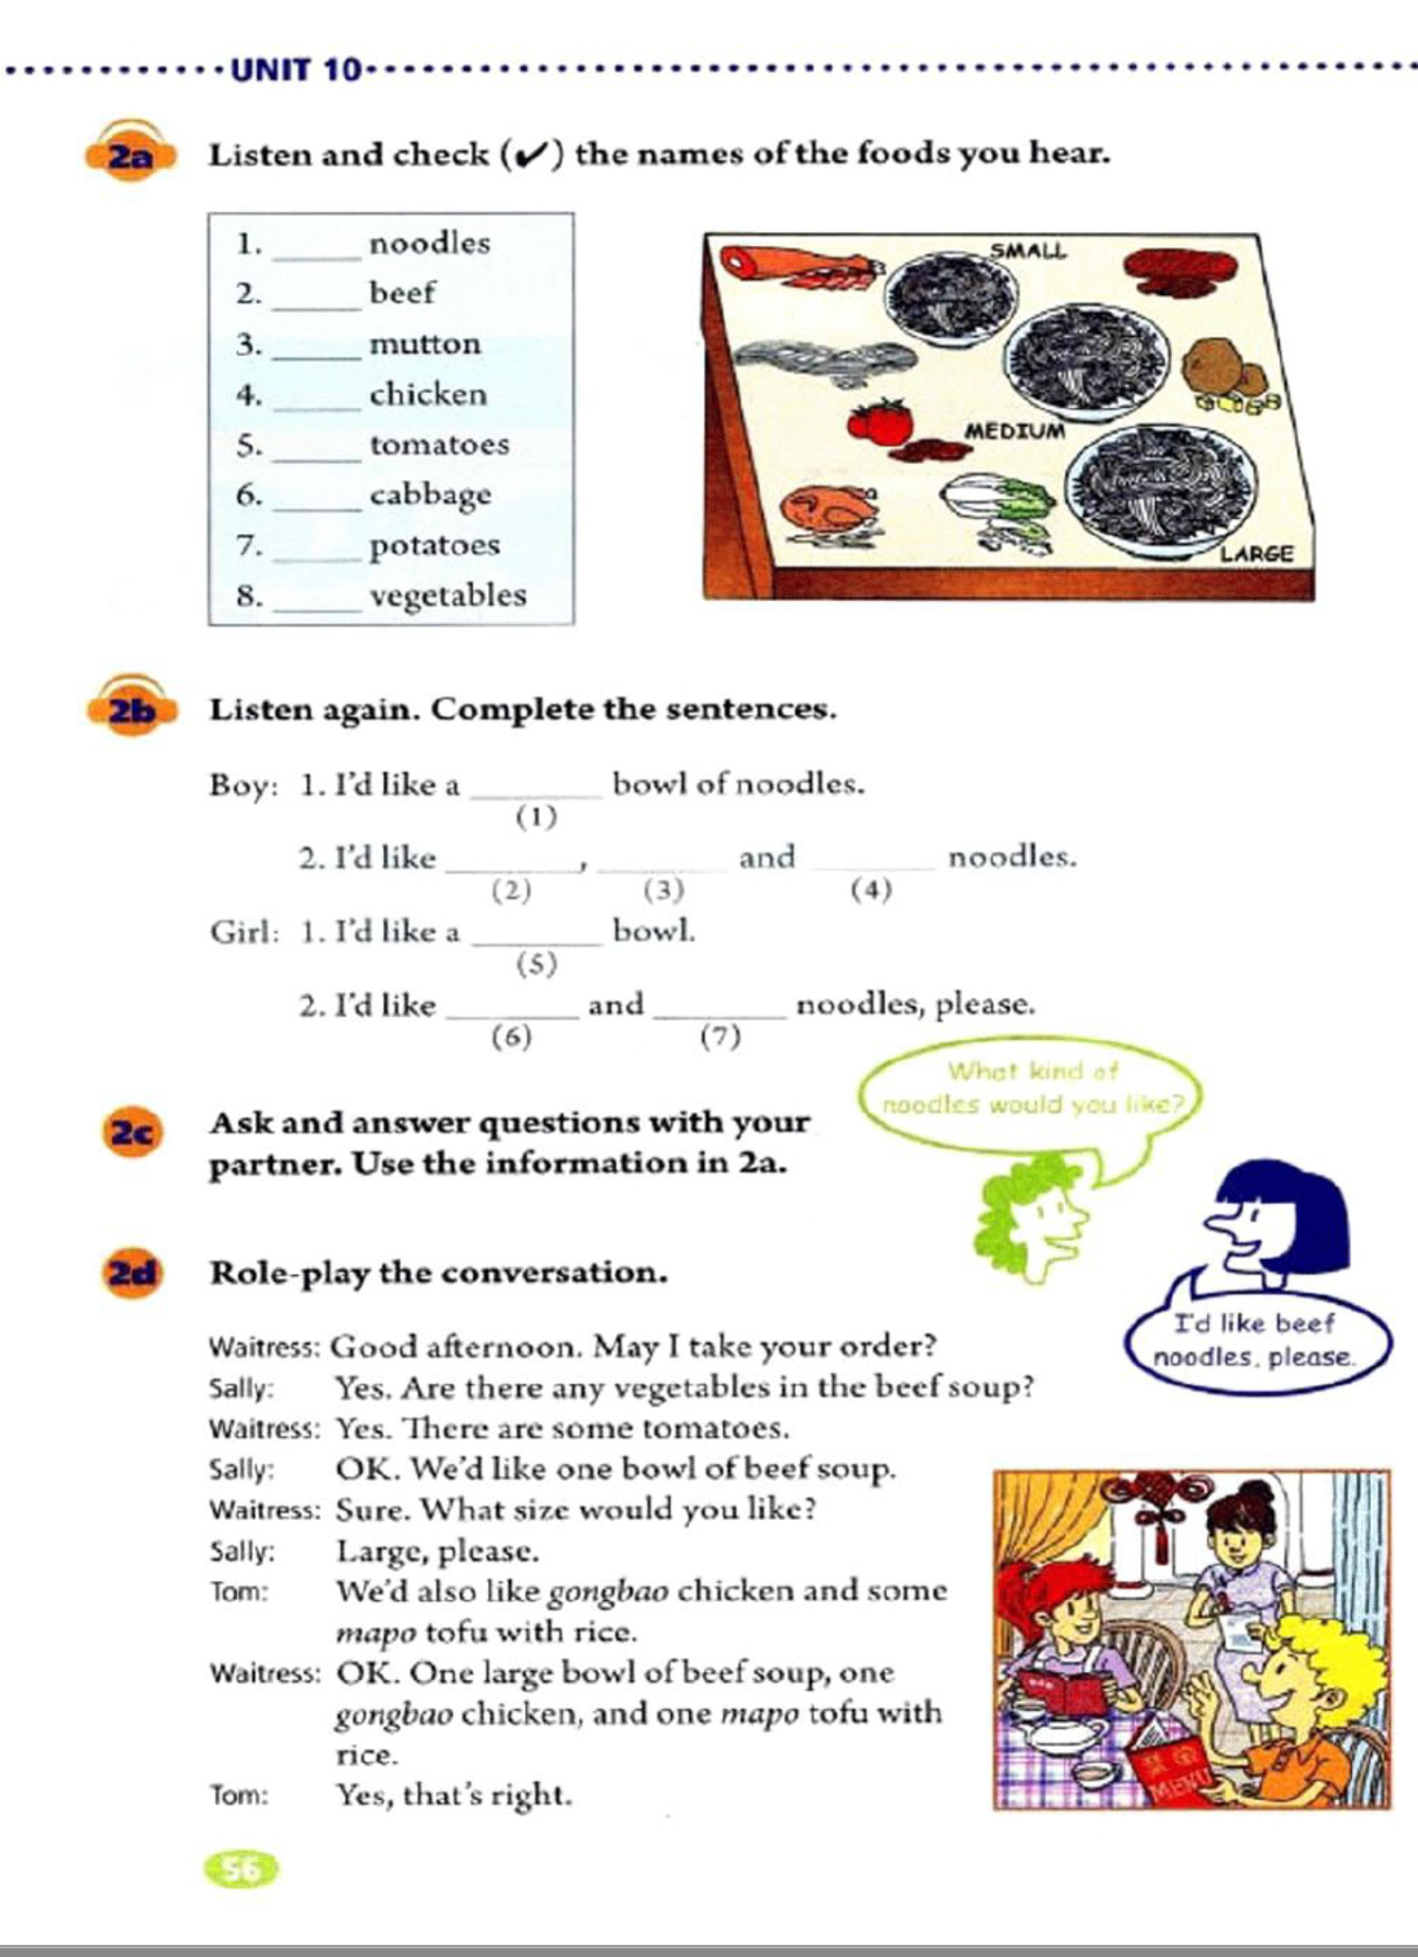

Teaching Plan
I. Teaching Aims / Objects / Goals:
___________________________________________________________________________
___________________________________________________________________________
___________________________________________________________________________
II. Teaching Important Points:
___________________________________________________________________________
___________________________________________________________________________
III. Teaching Difficult Points:
___________________________________________________________________________
___________________________________________________________________________
IV. Teaching Procedures:
___________________________________________________________________________
___________________________________________________________________________
___________________________________________________________________________
___________________________________________________________________________
___________________________________________________________________________
___________________________________________________________________________
___________________________________________________________________________
___________________________________________________________________________
___________________________________________________________________________
___________________________________________________________________________
___________________________________________________________________________
___________________________________________________________________________
___________________________________________________________________________
___________________________________________________________________________
___________________________________________________________________________
___________________________________________________________________________
___________________________________________________________________________
___________________________________________________________________________
V. Blackboard Design:

